Home Network (Virtual)

The goal of this project is to allow me to gain network device configuration experience with routers, switches and hosts. I also wanted to get experience with network design and IP Address scheme planning. This project will outline the steps that I used to complete and run my own home network (virtually).

1) The Network Parts
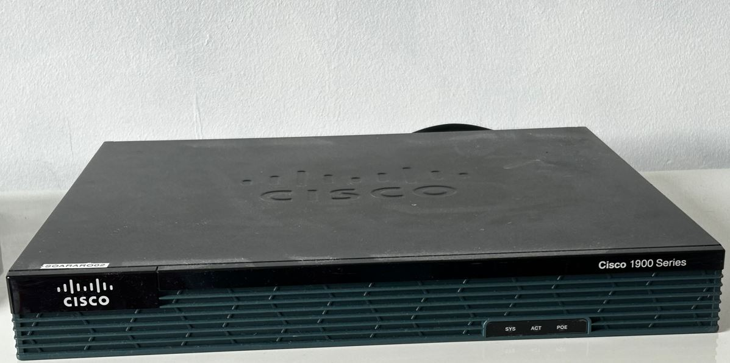

- 1x Router (Cisco 1900)
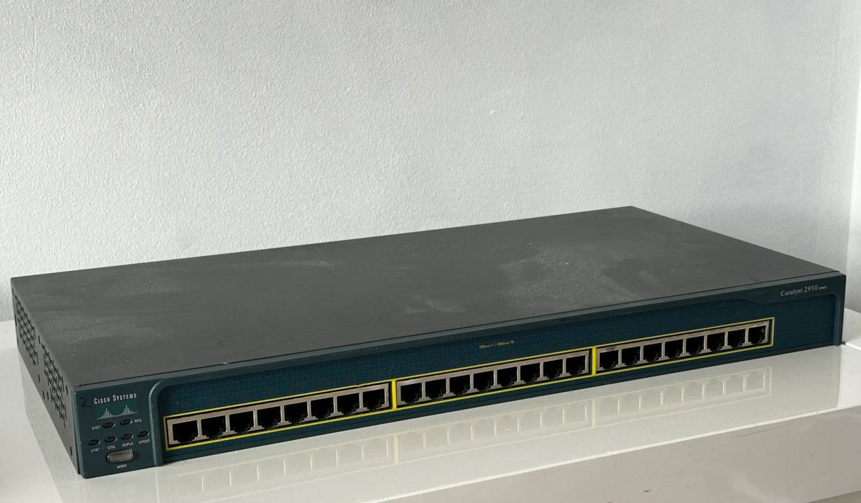
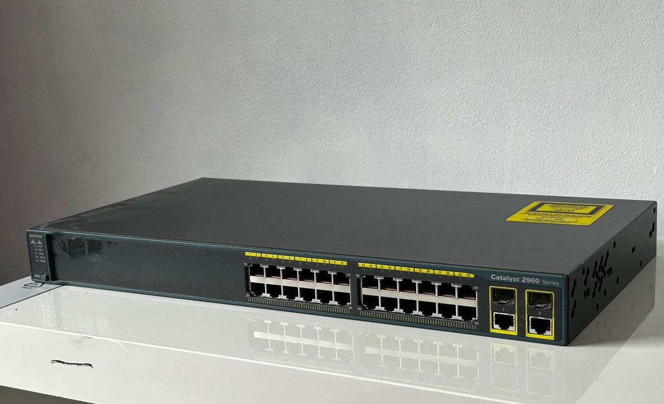

- 2x Switches (Cisco 2960)
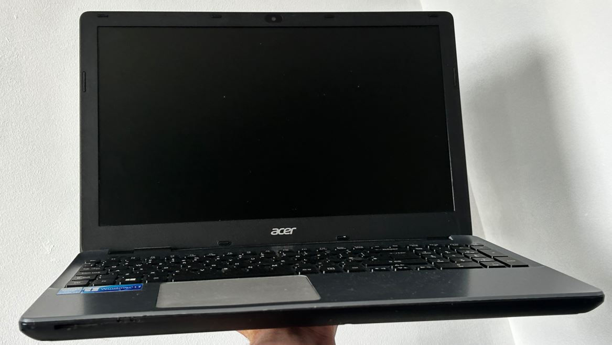

- 2x Hosts
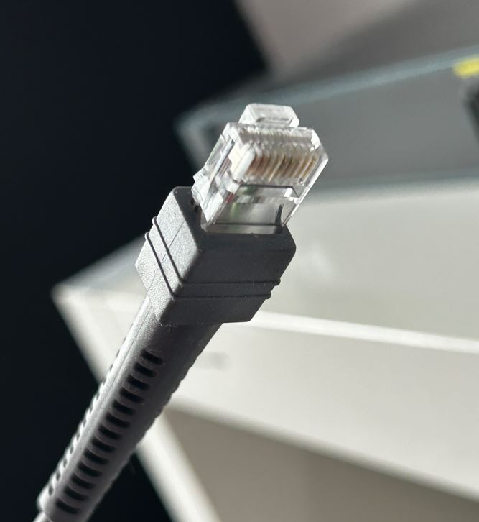
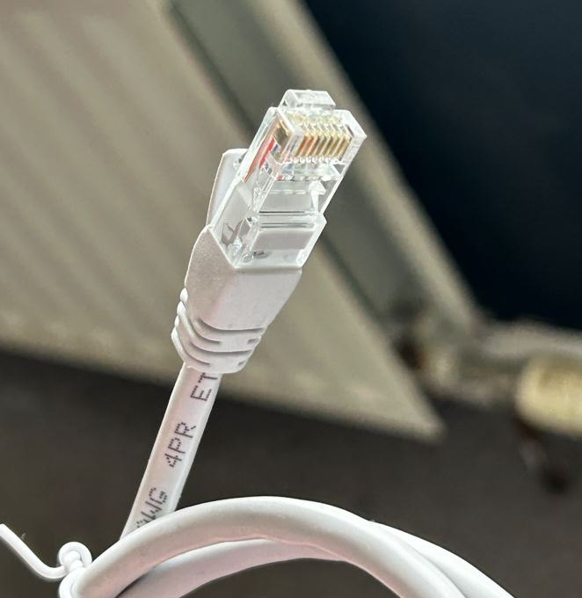

- 2x RJ-45-USB Cables - 3x Ethernet Cables
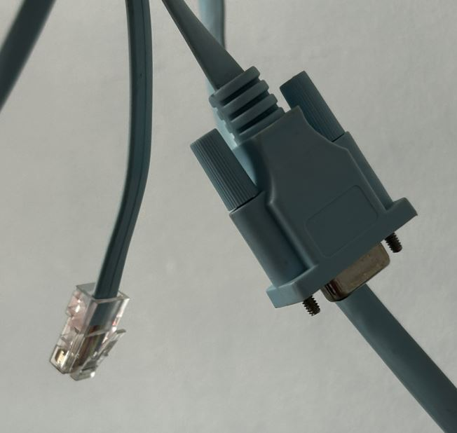

- 1x Console Cable

2) The Network Design + Why?
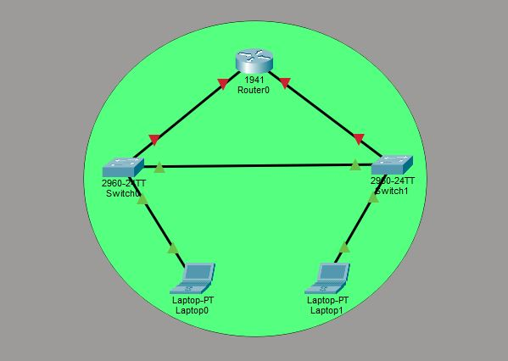

My network consists of 5 basic components; router, two switches and two hosts, arranged in a Hybrid-Mesh topology. The mesh area of the topology (router, two switches) has been put in place to provide path redundancy. For example, local traffic between Switch 0 and Switch 1 can bypass the router entirely, preventing congestion at the router interface. If the direct link between Switch 1 and Switch 0 fails, traffic from Laptop 1 can still potentially find an alternate logical path depending on how the routing protocols and Spanning Tree are configured.

The second part of the topology has been arranged in a tree/star fashion (Switches 0 + 1 and the hosts). I have chosen this arrangement as it keeps the devices isolated from each other, so that if Laptop 1 (right) fails, Laptop 0 (left) will be completely unaffected and online. This arrangement also allows for network administrators to diagnose problems easily as faulty endpoints can be easily located.

3) IP Addressing Scheme

Device | IP Address | Subnet Mask
Router (Gigabit Ethernet 0/0) | 192.168.0.1 | 255.255.255.240
Laptop 0 | 192.168.0.3 | 255.255.255.240
Router (Gigabit Ethernet 0/1) | 192.168.1.1 | 255.255.255.240
Laptop 1 | 192.168.1.3 | 255.255.255.240

My IP Addressing scheme consists of 5 addresses ranging from 192.168.0.1-5 with a 255.255.255.240 subnet mask. I decided to go with a /28 (255.255.255.240) as it allows me a total of 14 usable addresses. Two of these addresses have been reserved for the Network Address (to identify the network) and Broadcast Address (to send messages to the entire network) and five of these addresses have been used for my networking components. The remaining nine addresses (192.168.0.6-14) will allow me to expand this network in the future.

4) The Configurations

Router 1900

Name
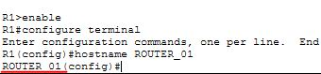

Banner
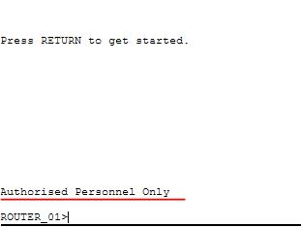

Password
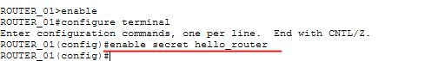

IP Address (Gigabit Ethernet 0/0)
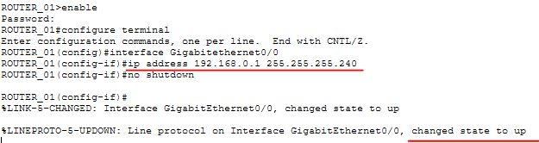
IP Address (Gigabit Ethernet 0/1)
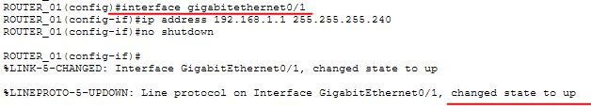
Switch 0 (2960)

Name
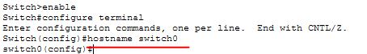

Banner

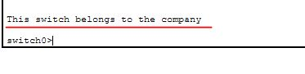

Interface Shutdowns
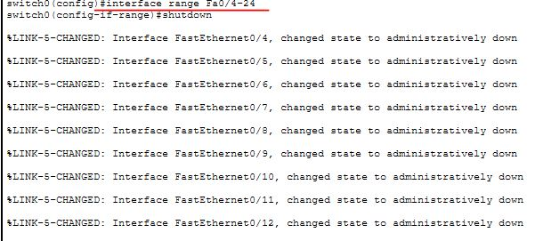
Switch 1 (2960)

Name
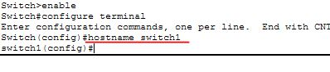

Banner
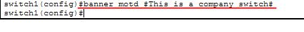

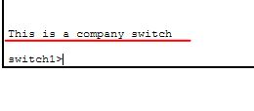

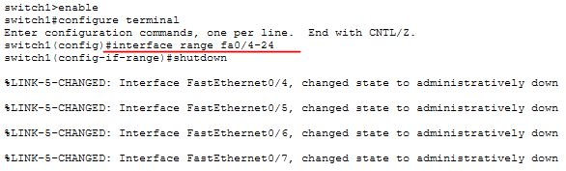
Interface Shutdowns
Laptop 0
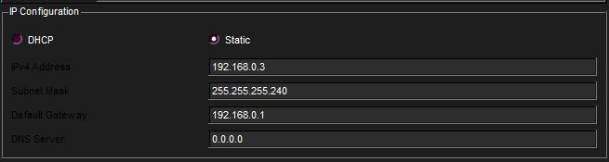
Laptop 1

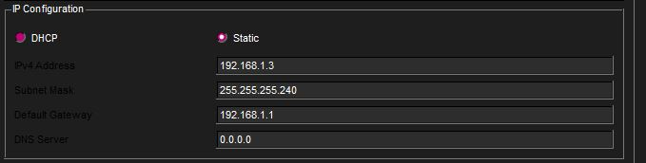

5) The Results (Ping Tests)

Laptop 0 → Laptop 1
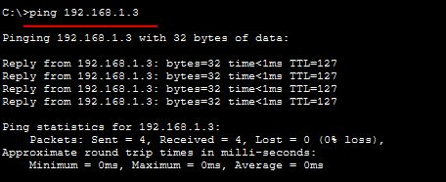

Laptop 1 → Laptop 0
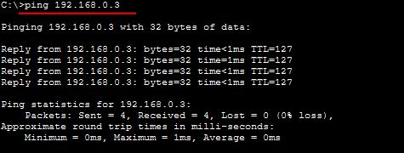

Laptop 0 → Gigabit Ethernet 0/0 and Gigabit Ethernet 0/1
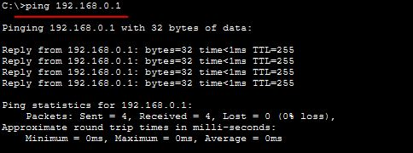

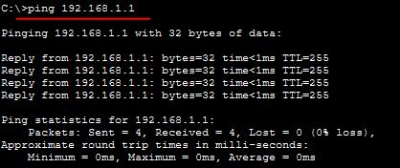

Laptop 1 → Gigabit Ethernet 0/1 and Gigabit Ethernet 0/0
